# Calendars for lab space and equipment

## Objectives

Sign up to reserve space and equipment to ensure their availability and avoid overlapping with others for our smooth workflows.

## Procedures

First time user, please email JiJY (jijy.isu@gmail.com) with your gmail account to get access to the calendars.

Prior to usage, reserve space and/or equipment with your name and brief activity and a well estimated timeline according to your work plans (see example on weeks of 7/15/19 - 7/26/19).

### GERMS: Subsampling bench

[This calendar](https://calendar.google.com/calendar/b/1?cid=aXYxZjlycm00ZDRma2hsNzNha3NlZHFxaHNAZ3JvdXAuY2FsZW5kYXIuZ29vZ2xlLmNvbQ) is for the bench space on the right side of the lab when you walk in. The space is used for subsampling soil samples (scales area) and filtering water samples (vacuum manifolds area). Please include sample type when you reserve the space.

|  |  |
| --- | --- |
| Scales area for soil samples | Vacuum manifolds area for water samples |

### GERMS: DNA sample preparation bench

[This calendar](https://calendar.google.com/calendar/b/1?cid=NjBnajNiZDVuOHQxczA5NDhwaDd1amlkYjhAZ3JvdXAuY2FsZW5kYXIuZ29vZ2xlLmNvbQ) is for the right side of middle bench in the lab. This area is for handling DNA samples and samples that have been subsampled into DNA extraction tubes for DNA extraction. There are at least two spaces that people can work comfortably without interfering with each other, however, you may identify the activity that you will be working on (i.e. DNA extraction or qPCR prep etc.) to give other people the idea of what other instrument that may be occupied during the reserved time.

|  |  |
| --- | --- |
| DNA sample prep 1 | DNA sample prep 2 |

### 

### 

### 

### 

### GERMS: Robot

[This calendar](https://calendar.google.com/calendar/b/1?cid=a3ZqbXZhZmFhc2pjdTg4OHVobmZpcDJiOW9AZ3JvdXAuY2FsZW5kYXIuZ29vZ2xlLmNvbQ) is to reserve the Robot, there is also a log sheet next to the machine, please sign up before and after the usage as well as record problems (if any).

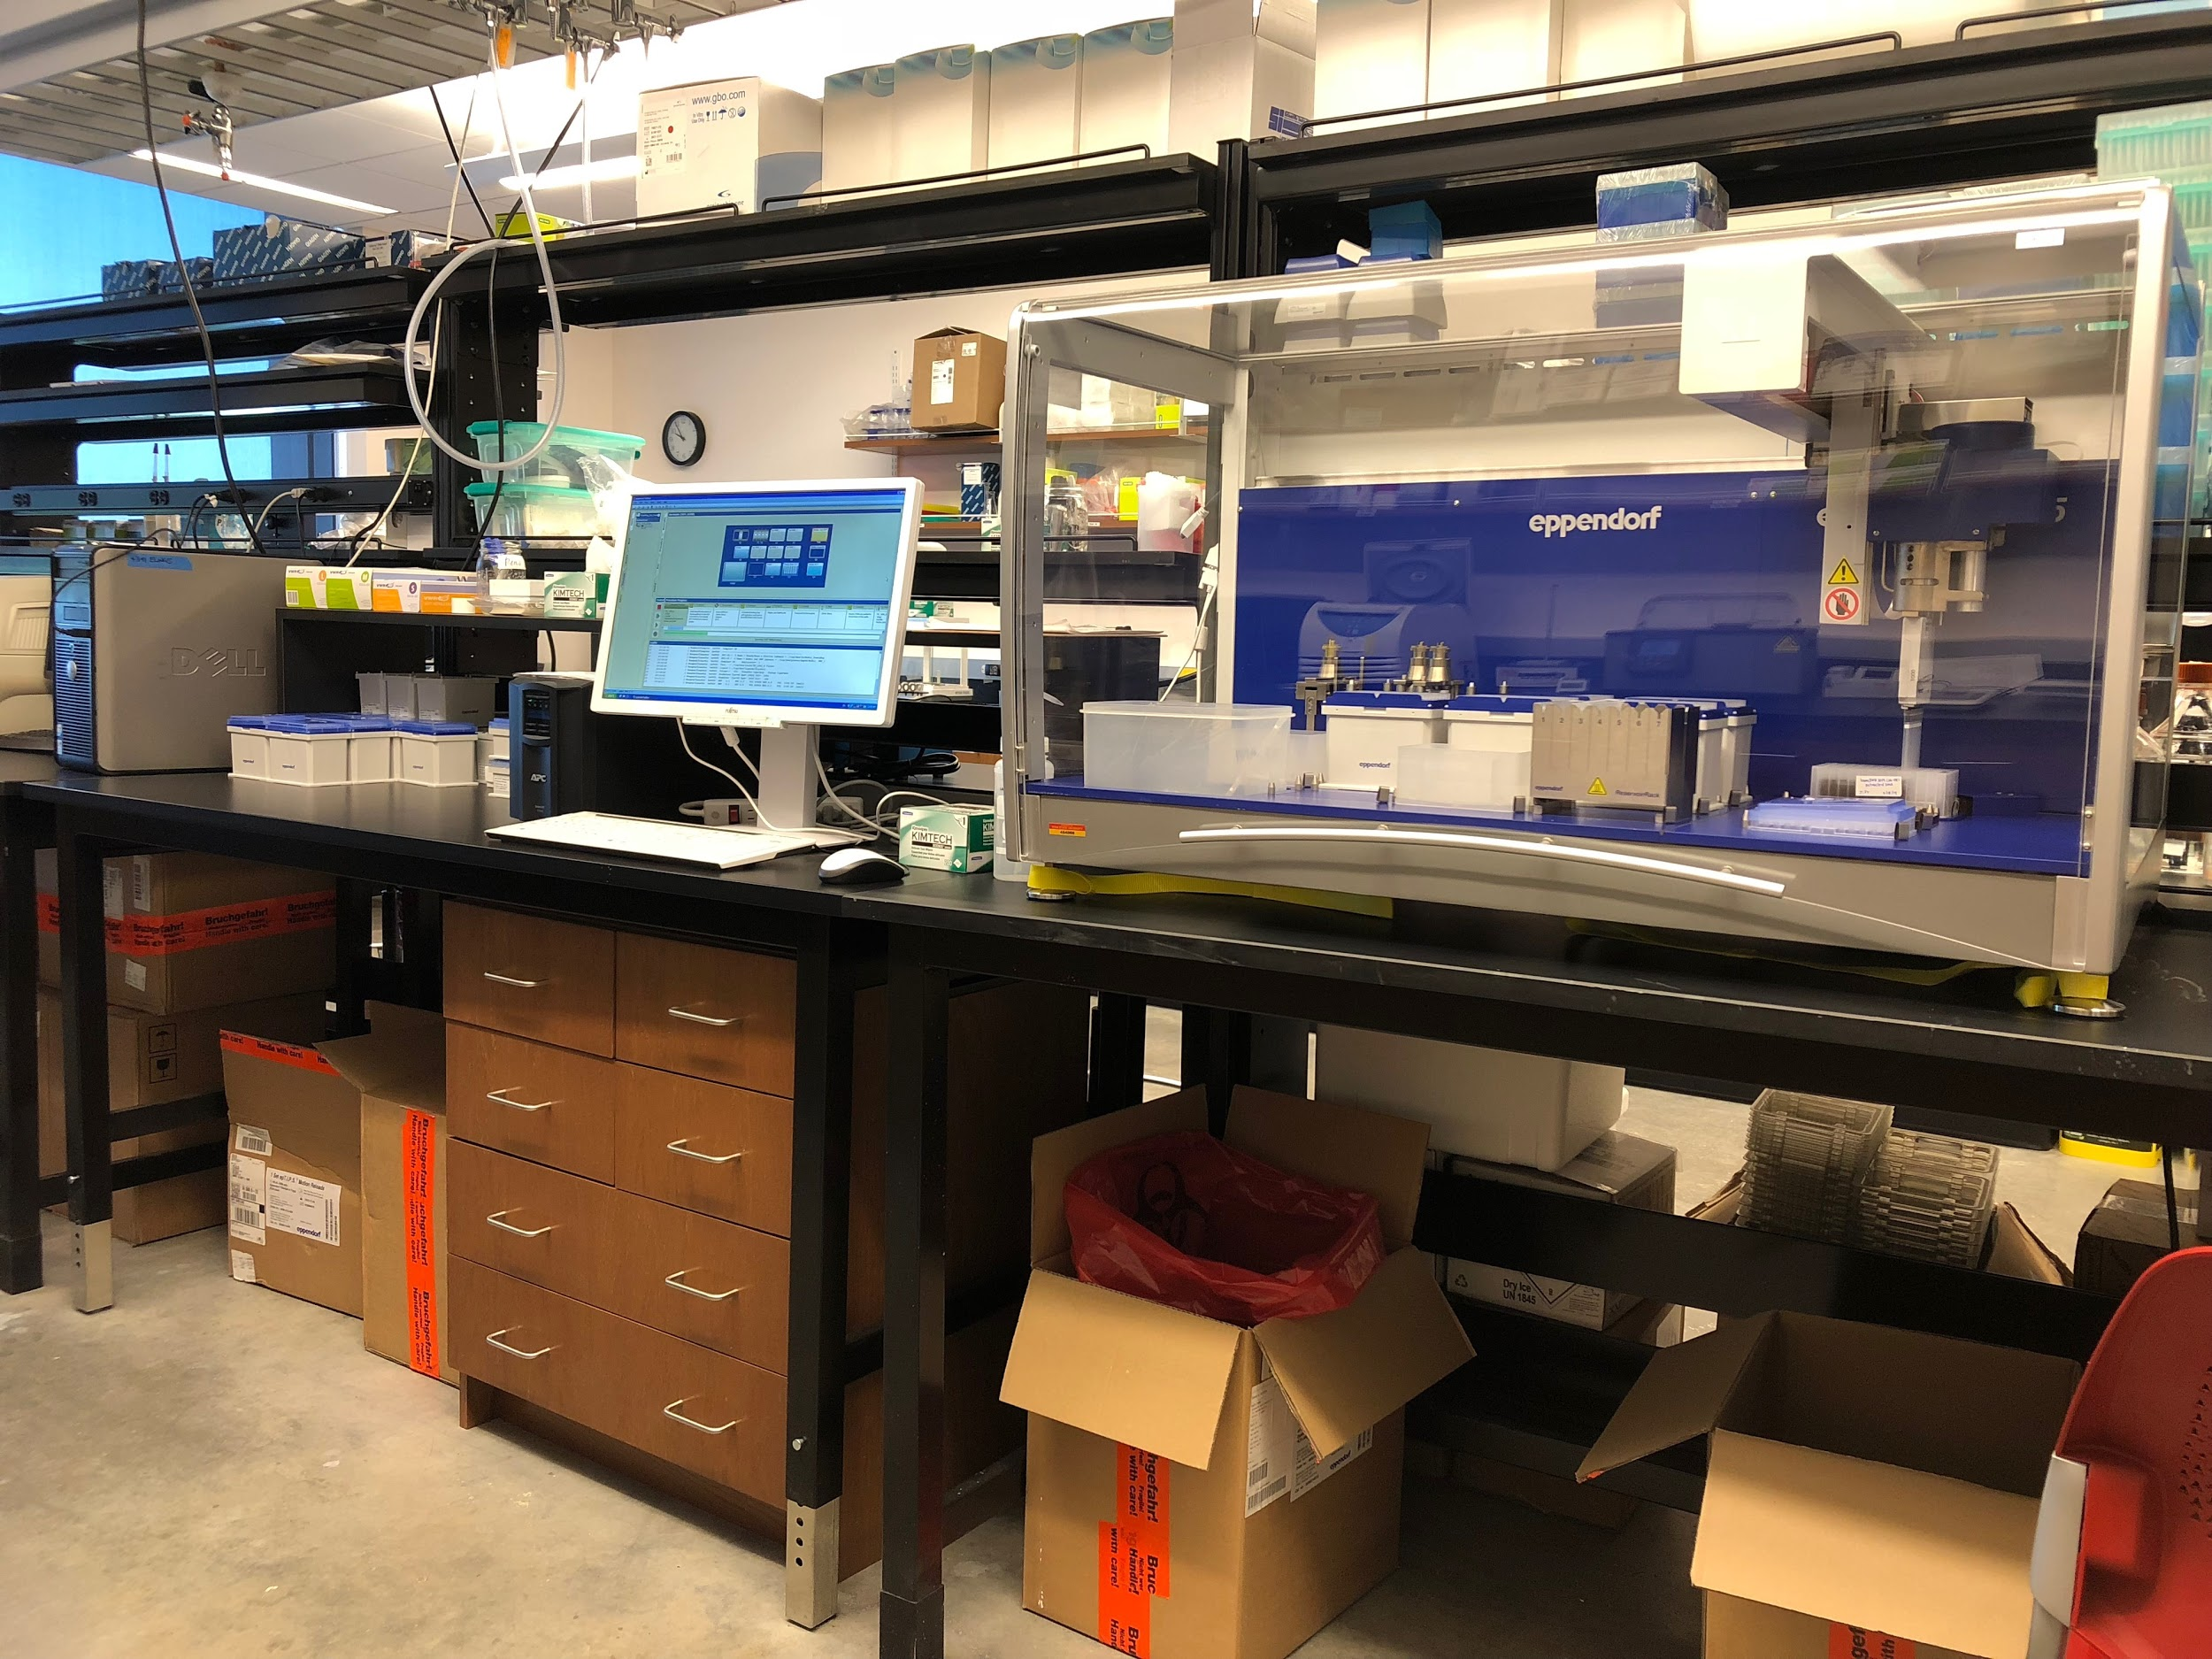

### 

### 

### 

### GERMS: PCR and qPCR

[This calendar](https://calendar.google.com/calendar/b/1?cid=cHJ1MmRsaGZndGdqM2xvdDdkc3FzM2FmMDBAZ3JvdXAuY2FsZW5kYXIuZ29vZ2xlLmNvbQ) is for both PCR and qPCR machines, please indicate which machine you will be using.

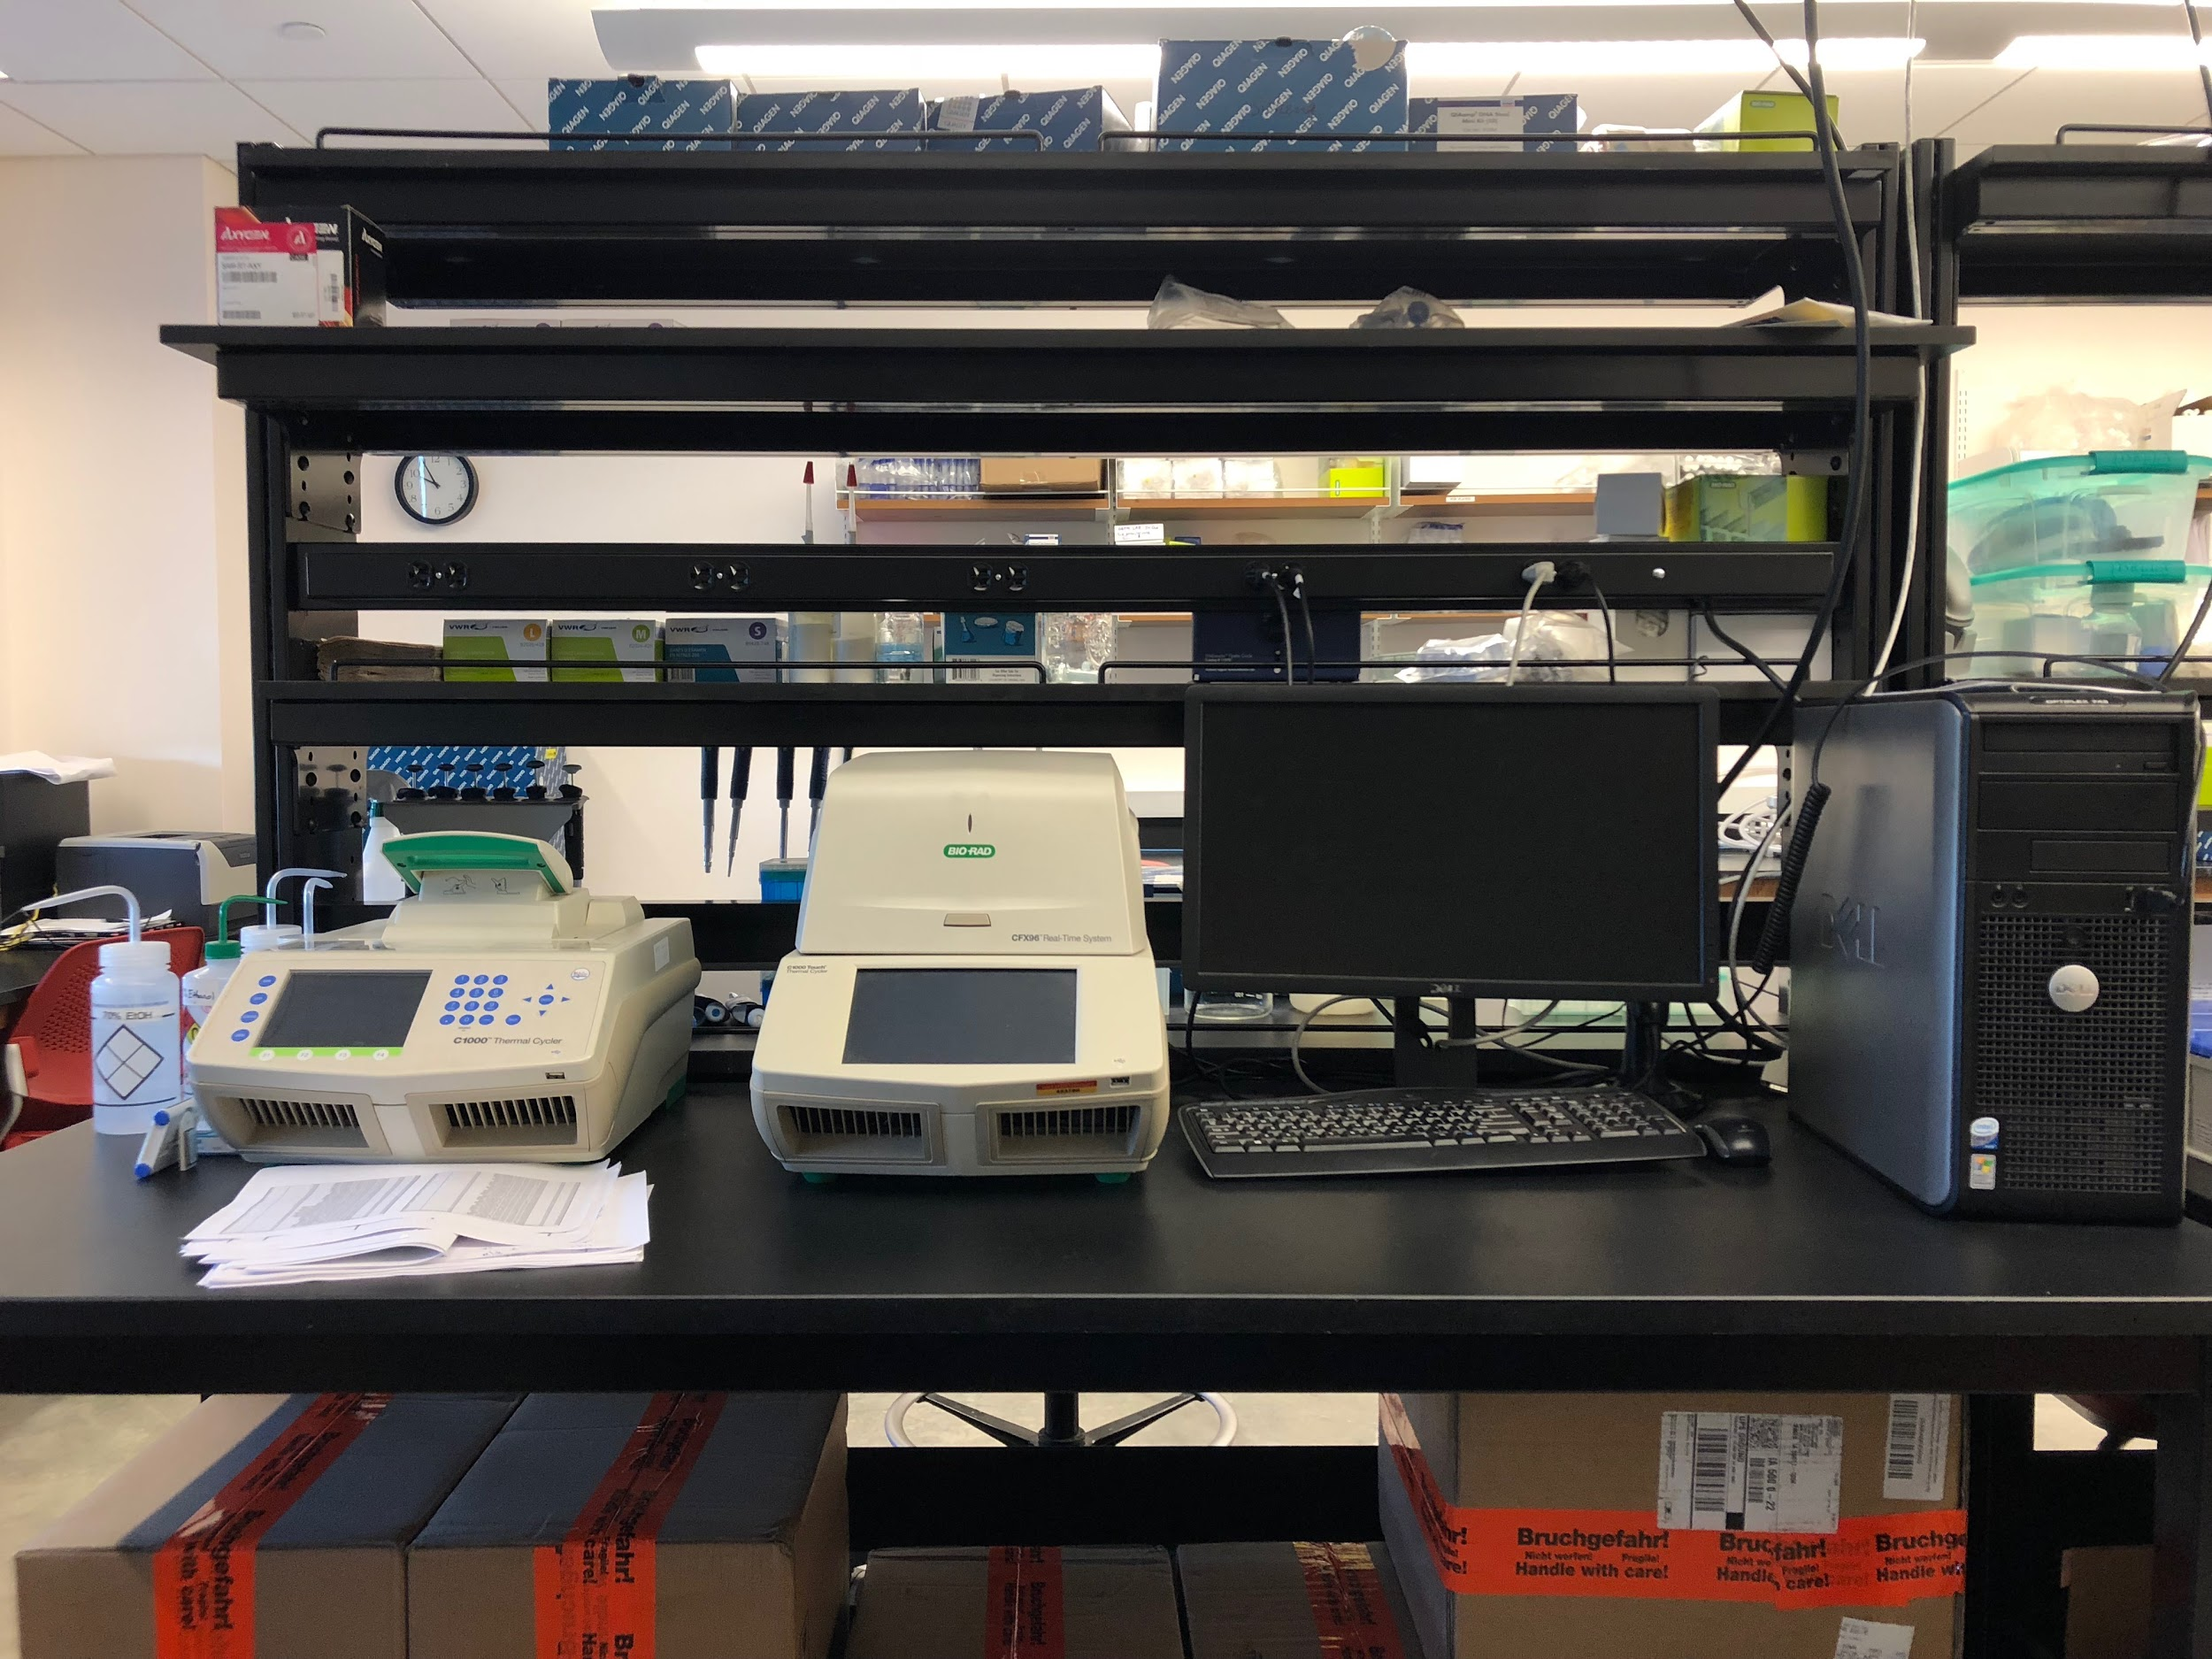

### GERMS: Biomark (coming up)